AWS DevOps Practical Tasks
VPC Peering Across Regions & S3 + CDN + Route 53 Static Website

Task 1: Configure VPC Peering in Cross Regions
Configure VPC Peering between two Amazon VPCs located in different AWS Regions. Verify that resources in the peered VPCs can communicate using their private IP addresses.

Objective
Establish private network connectivity between two VPCs in different AWS Regions using VPC Peering.

Requirements
- Two VPCs in different AWS Regions.
- Non-overlapping CIDR blocks for both VPCs.
- At least one EC2 instance in each VPC for connectivity testing.
- Security groups allowing the required test traffic.
- IAM permissions to create and modify VPC peering and route tables.

Tasks / Steps
1. Create or identify VPC-A in Region 1 with a CIDR such as 10.10.0.0/16.
2. Create or identify VPC-B in Region 2 with a different, non-overlapping CIDR such as 10.20.0.0/16.
3. Launch test EC2 instances in the appropriate subnets of both VPCs.
4. From VPC-A, create a VPC Peering Connection request to VPC-B in the other Region.
5. Switch to the Region containing VPC-B and accept the pending VPC peering request.
6. Update the route table associated with VPC-A so traffic destined for VPC-B CIDR is routed through the VPC peering connection.
7. Update the route table associated with VPC-B so traffic destined for VPC-A CIDR is routed through the VPC peering connection.
8. Update the EC2 security groups to allow the required private traffic between the two VPC CIDR ranges.
9. Verify the peering connection status is Active.
10. Test connectivity between the EC2 instances using private IP addresses. 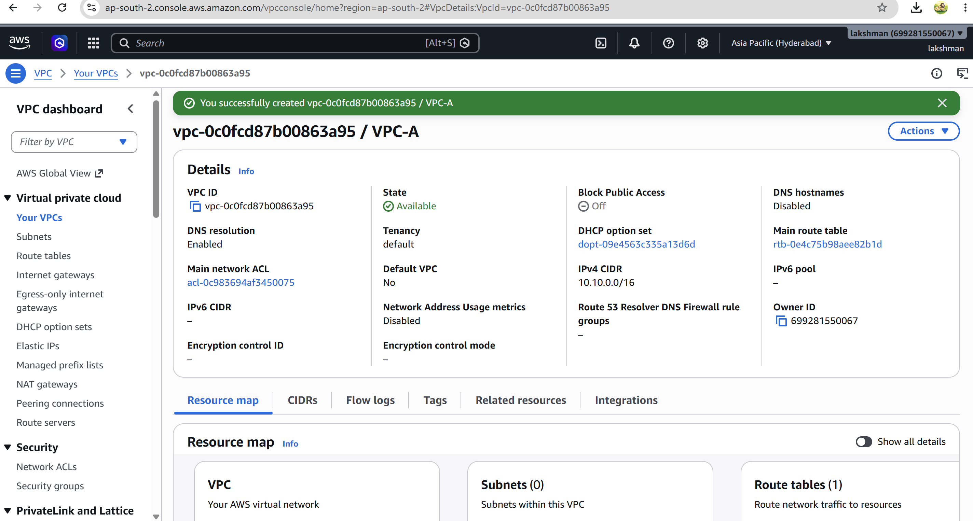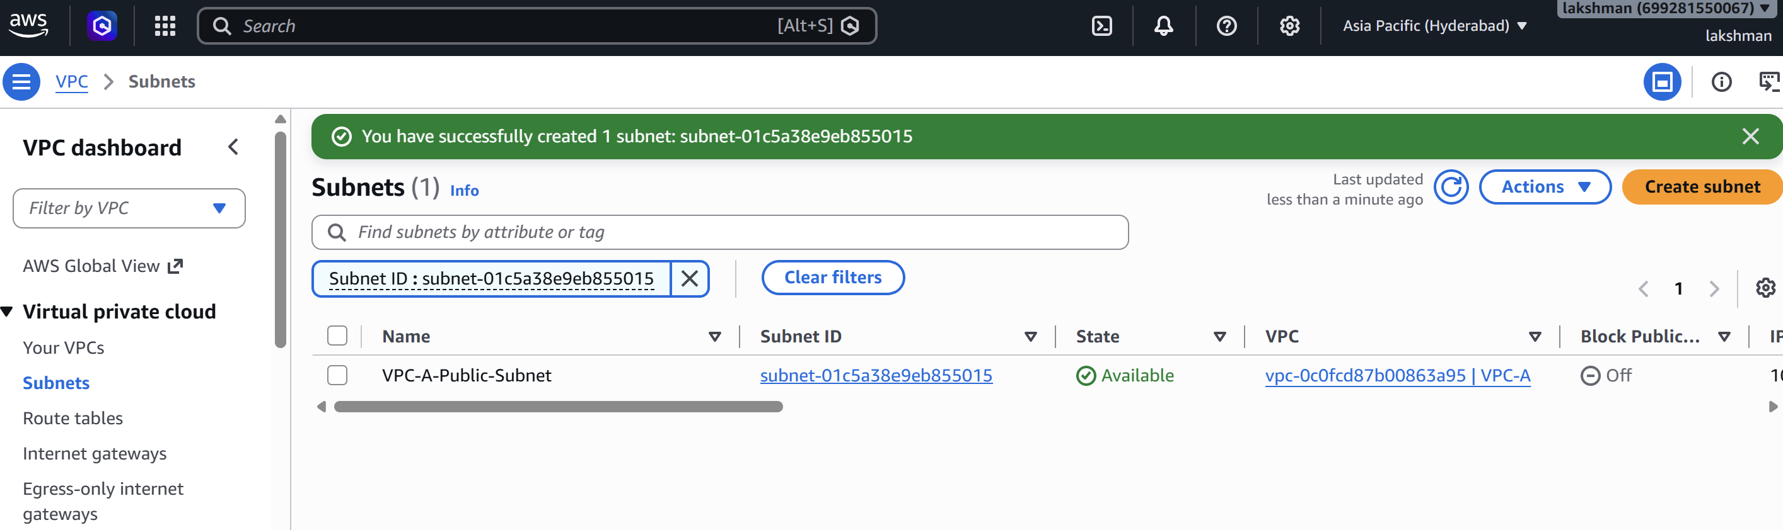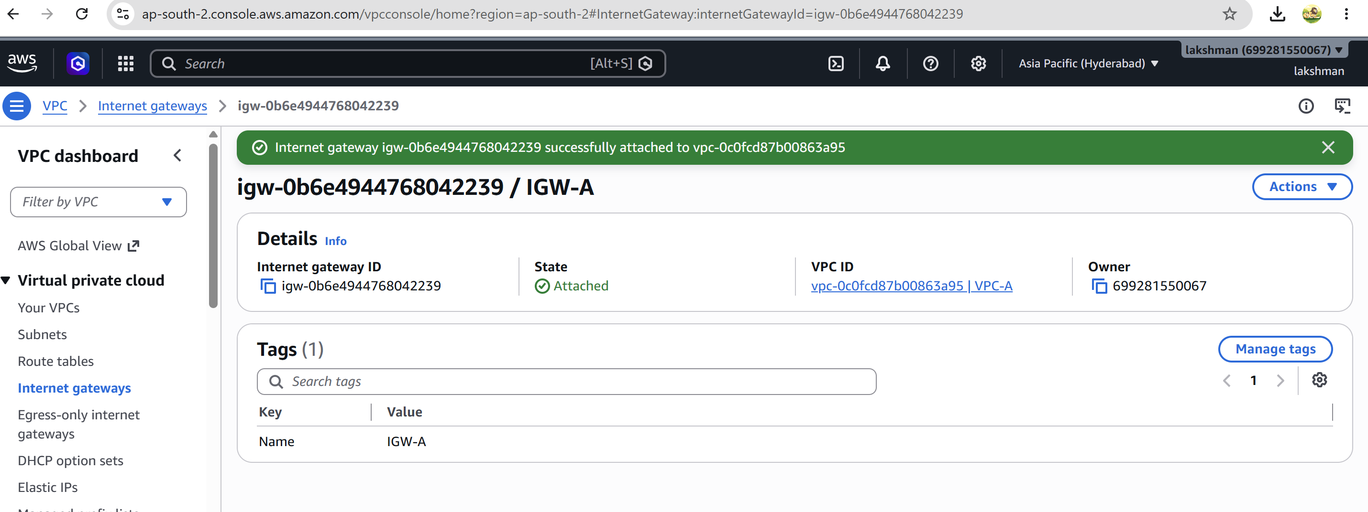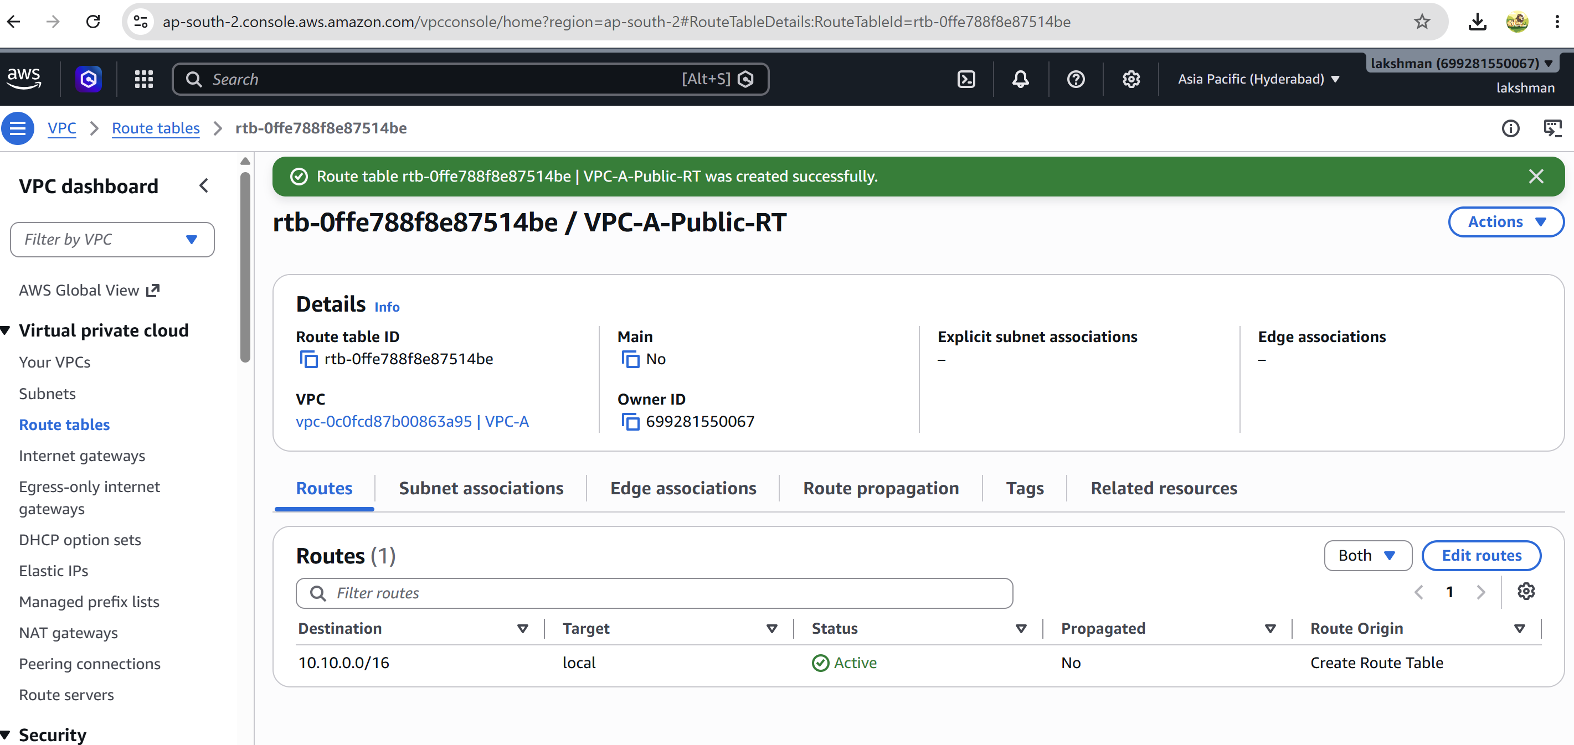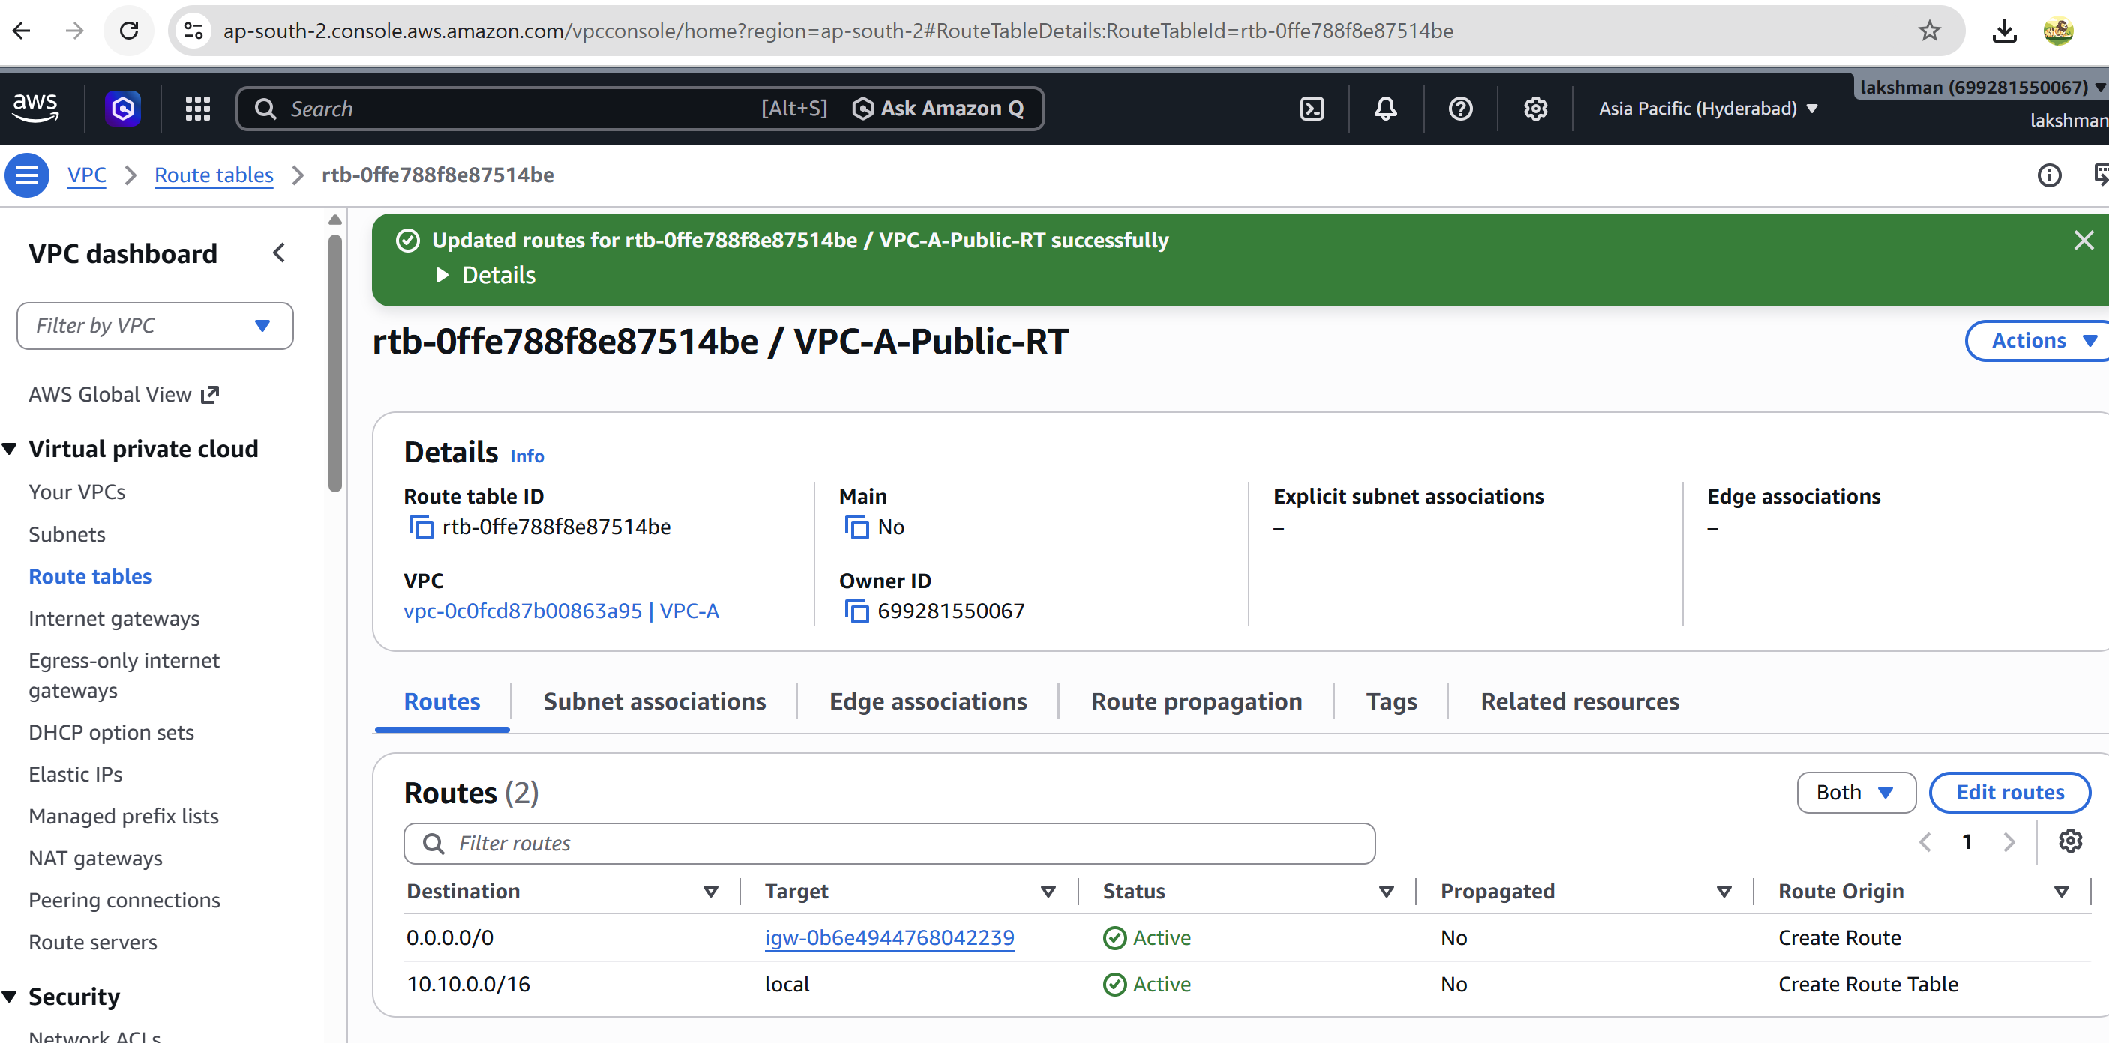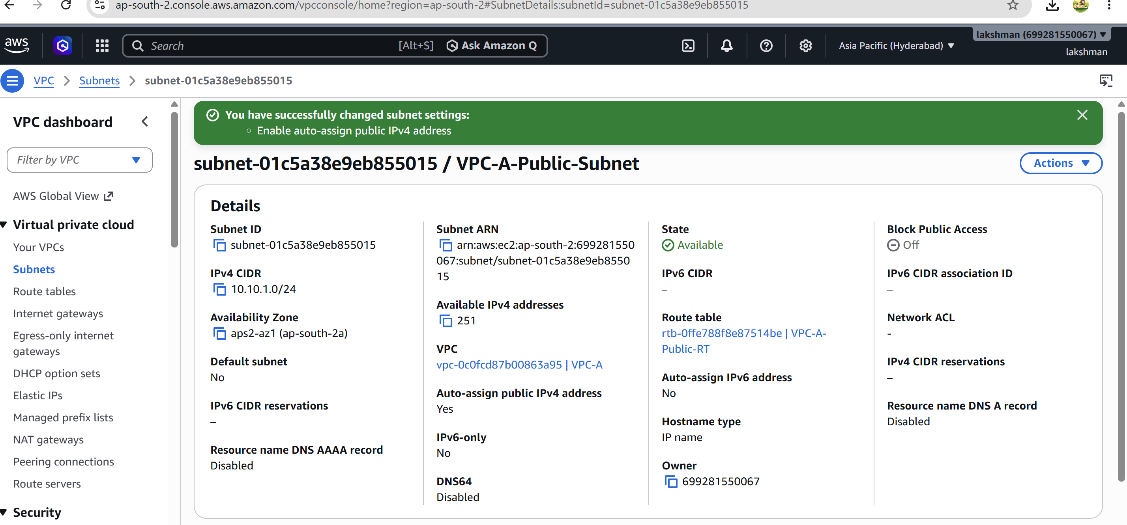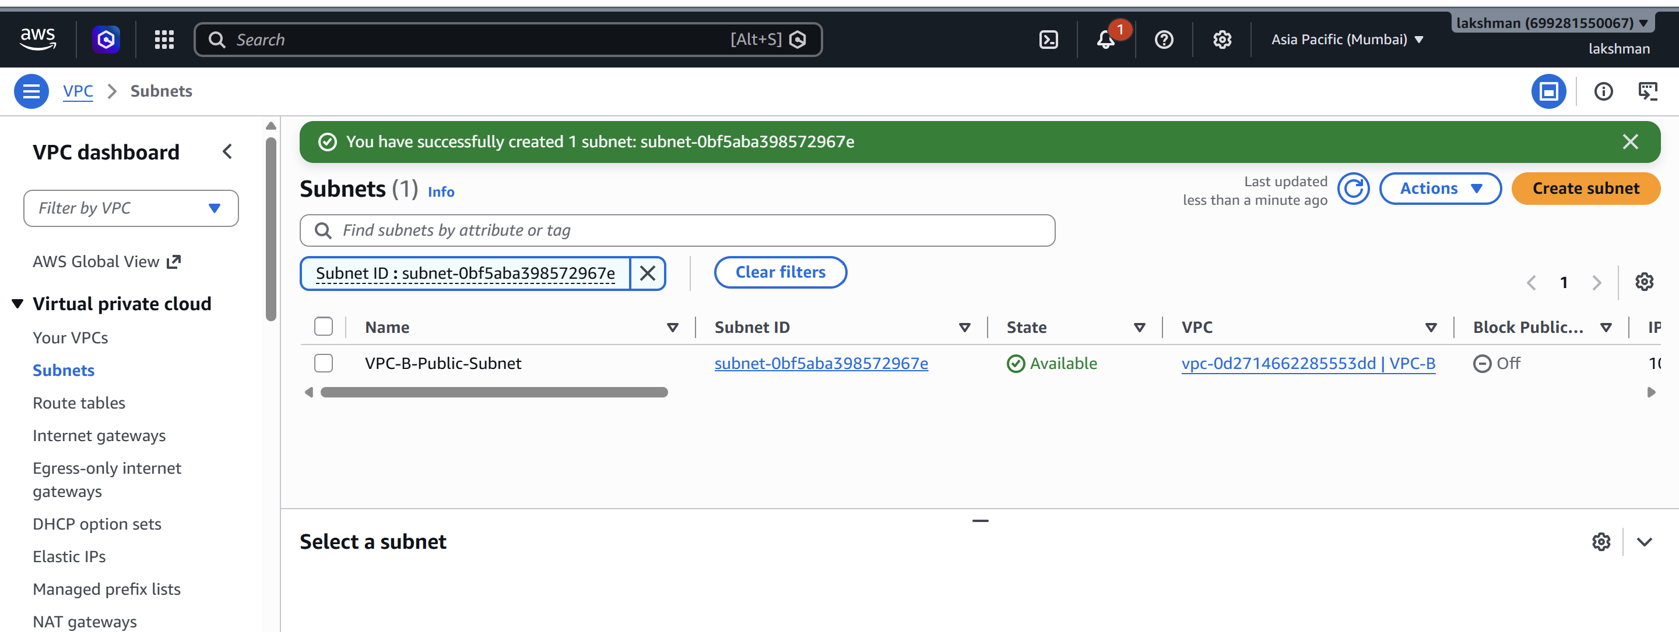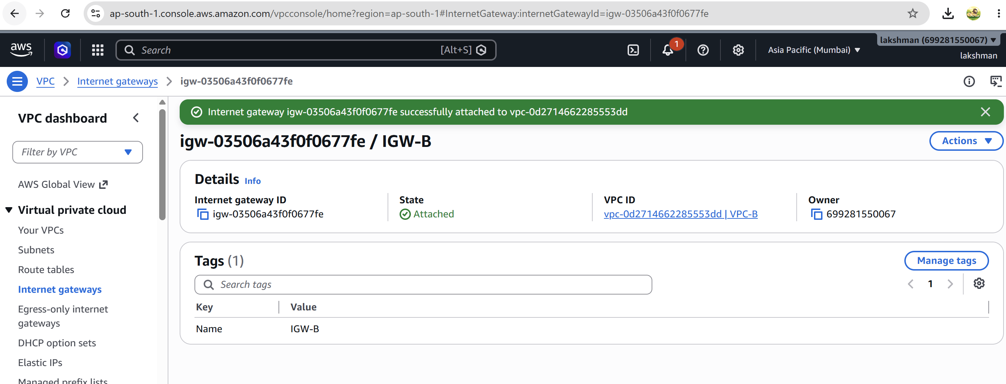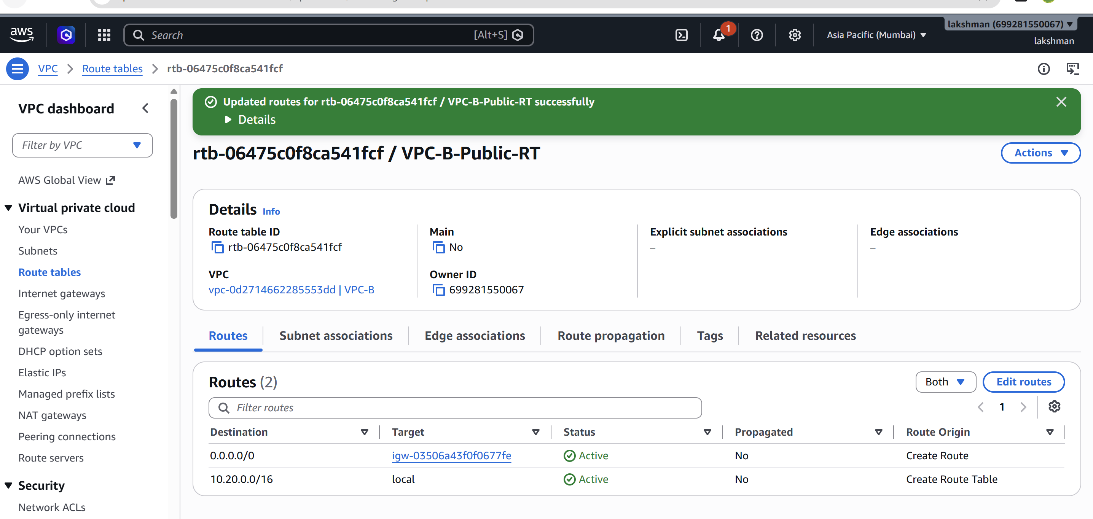ip-10-10-1-166.ap-south-2.compute.internal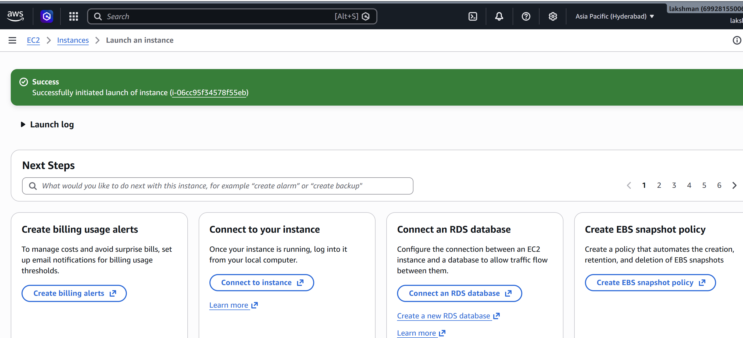Validation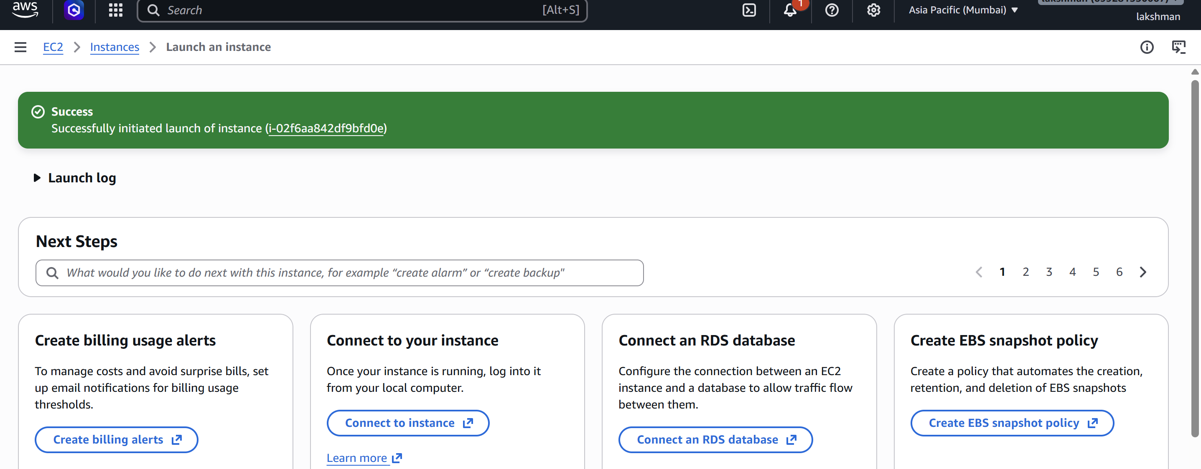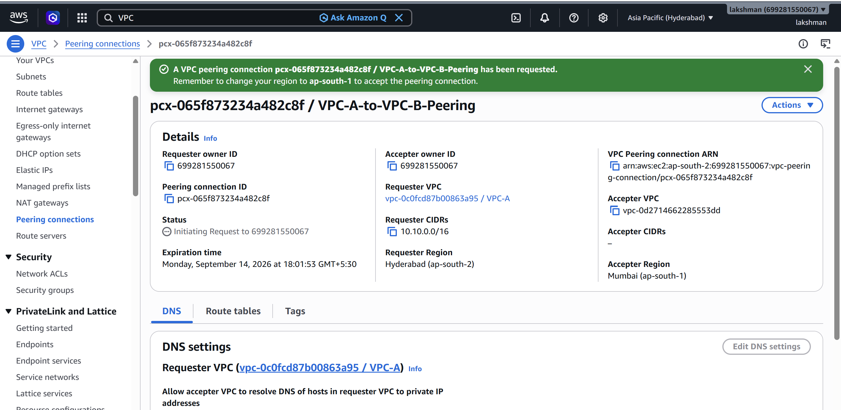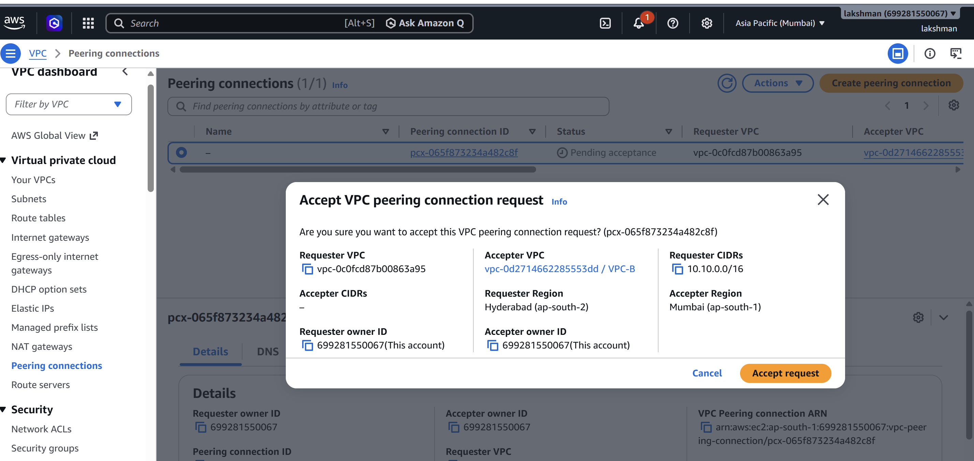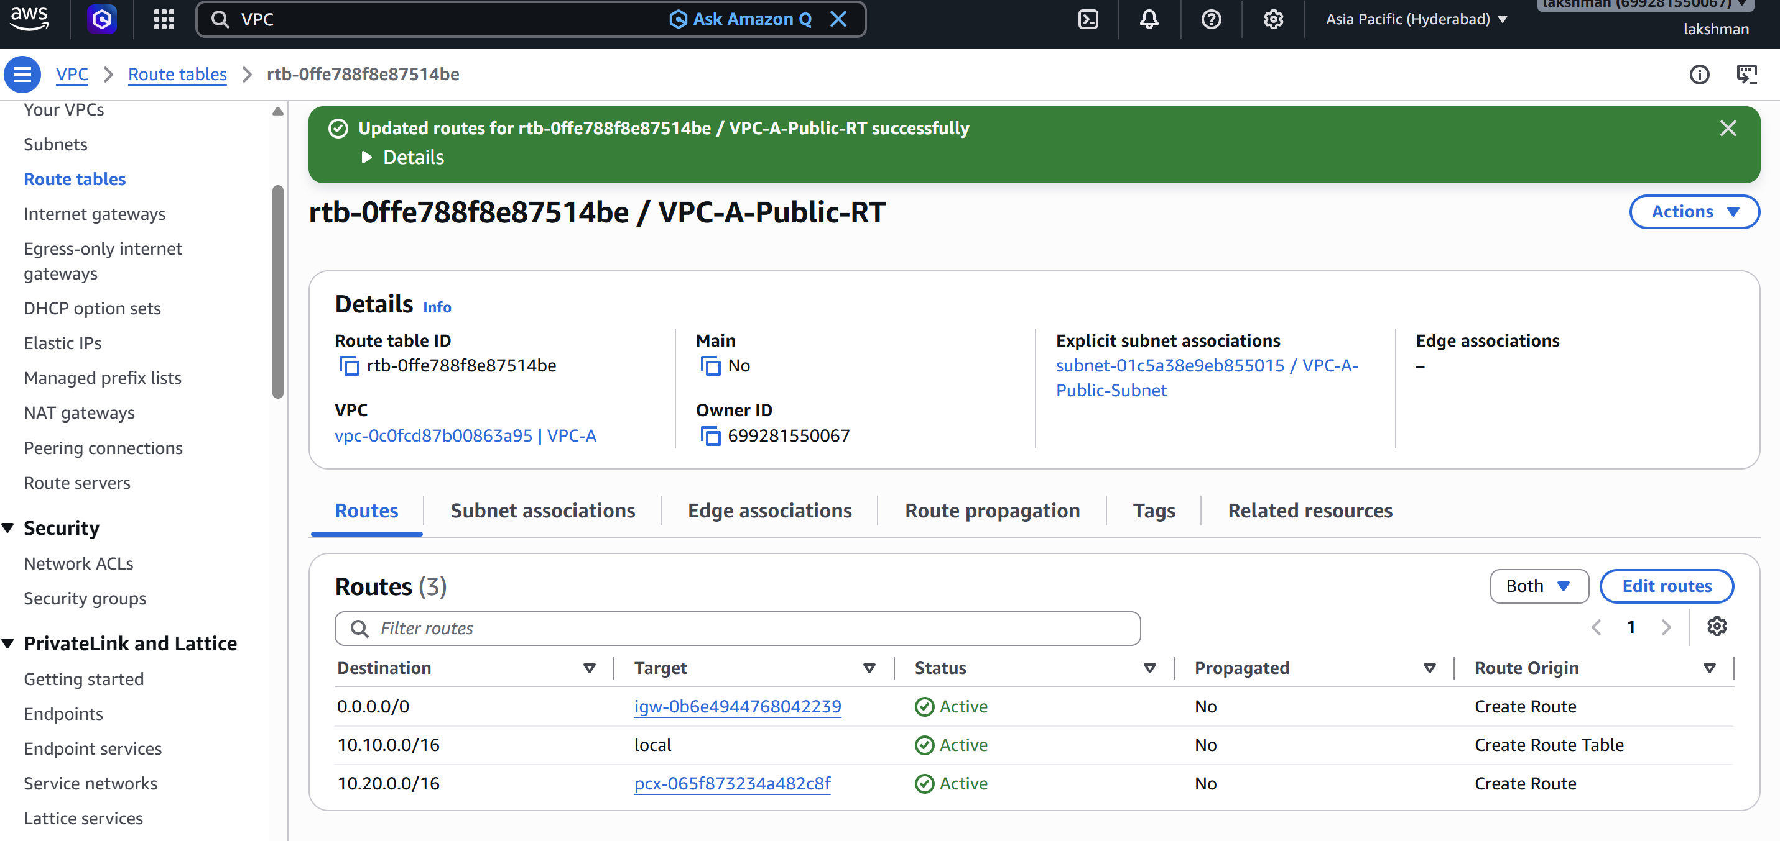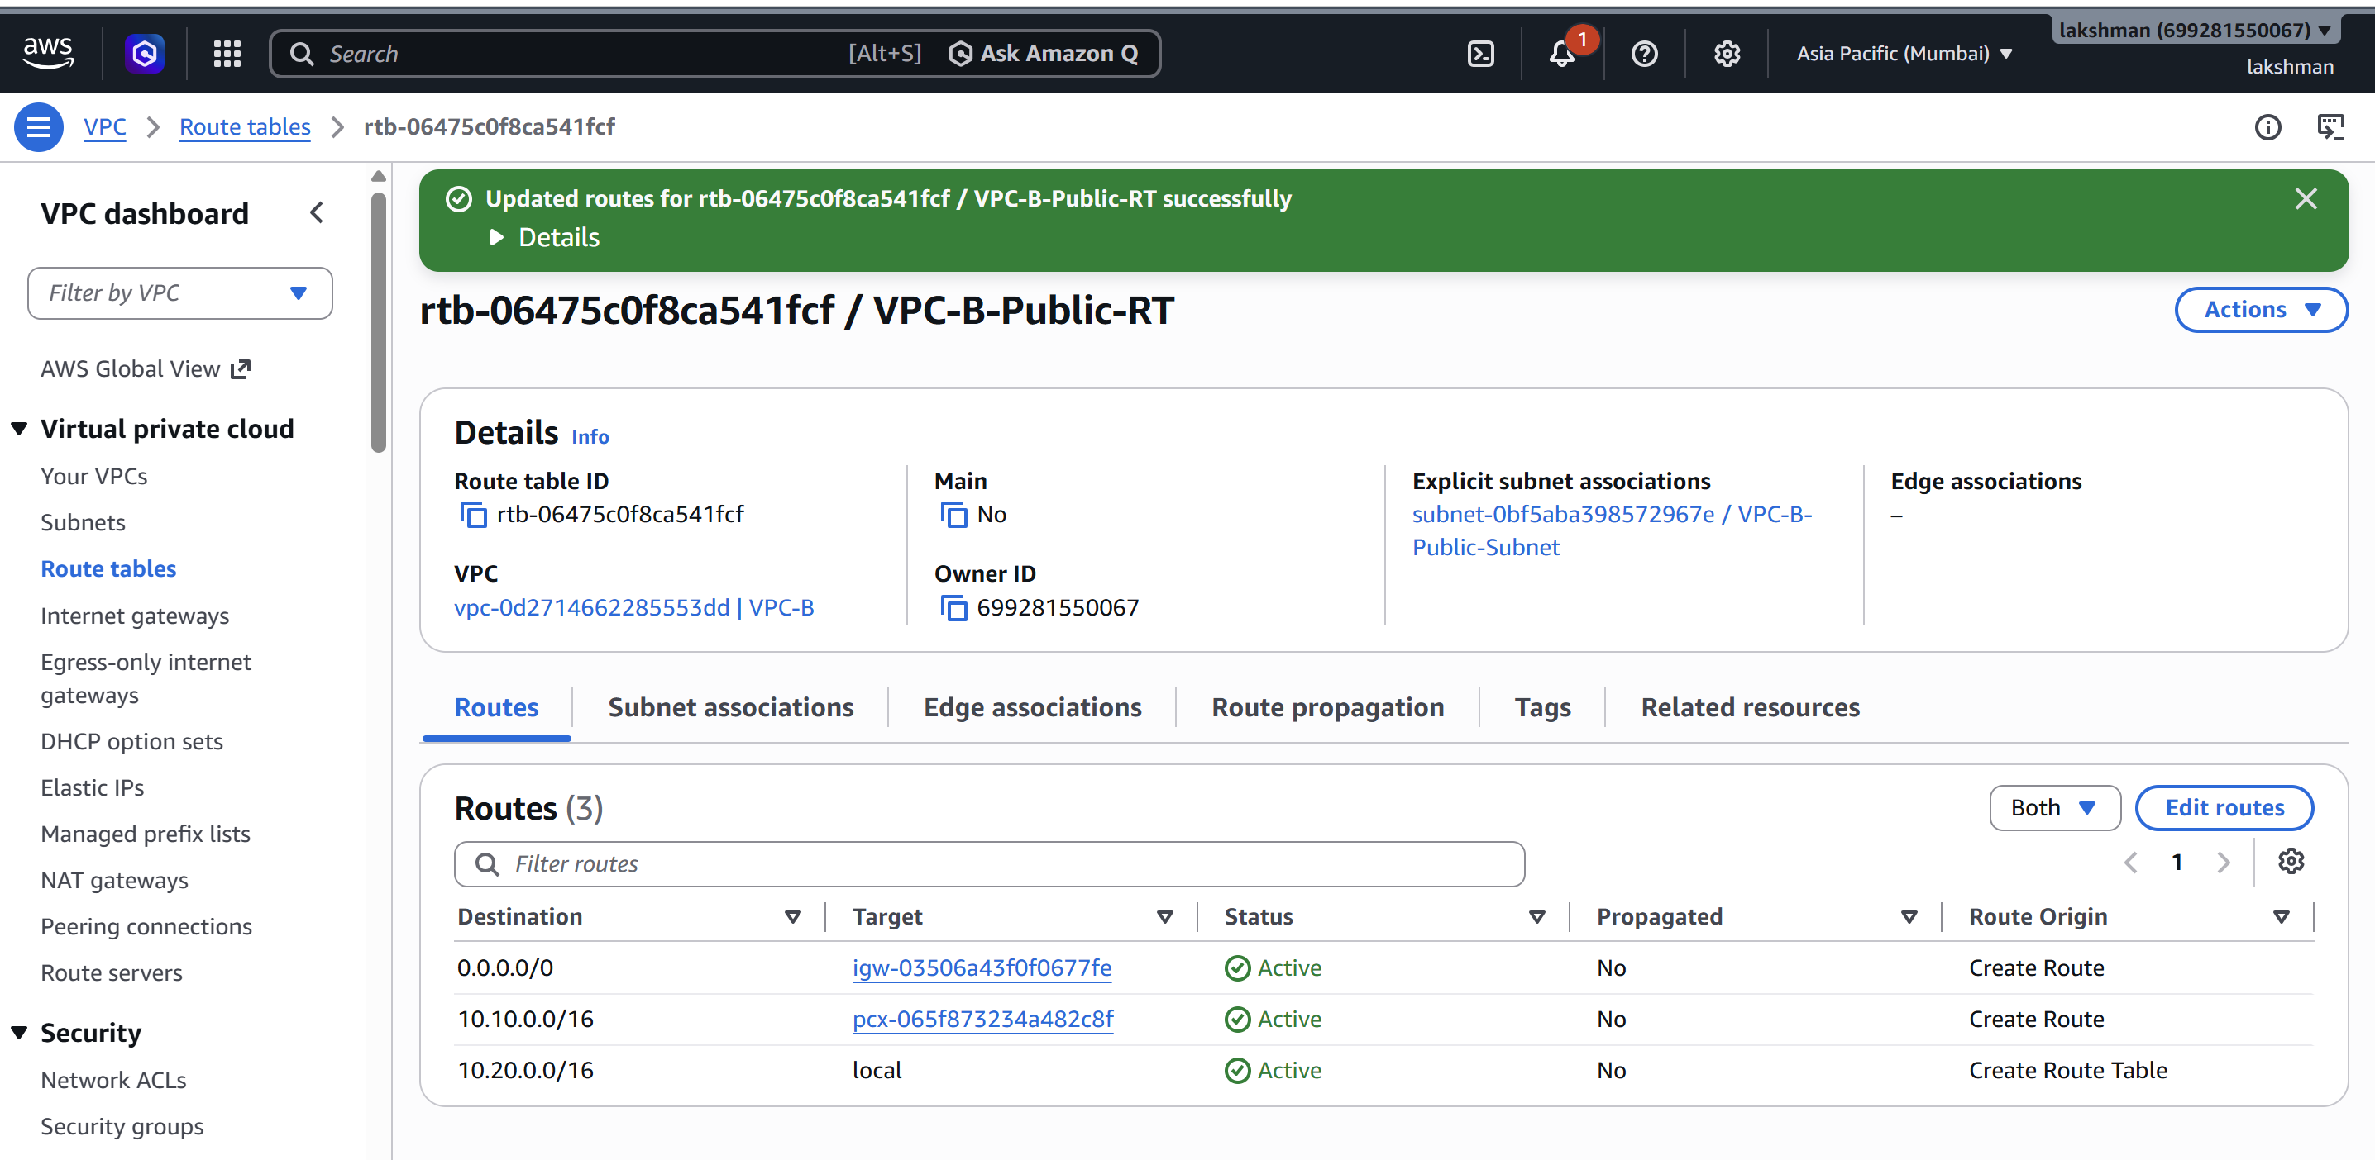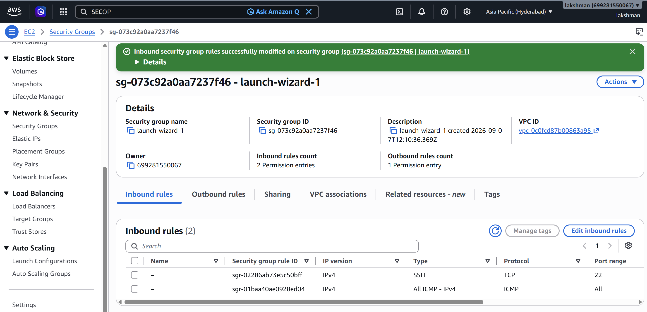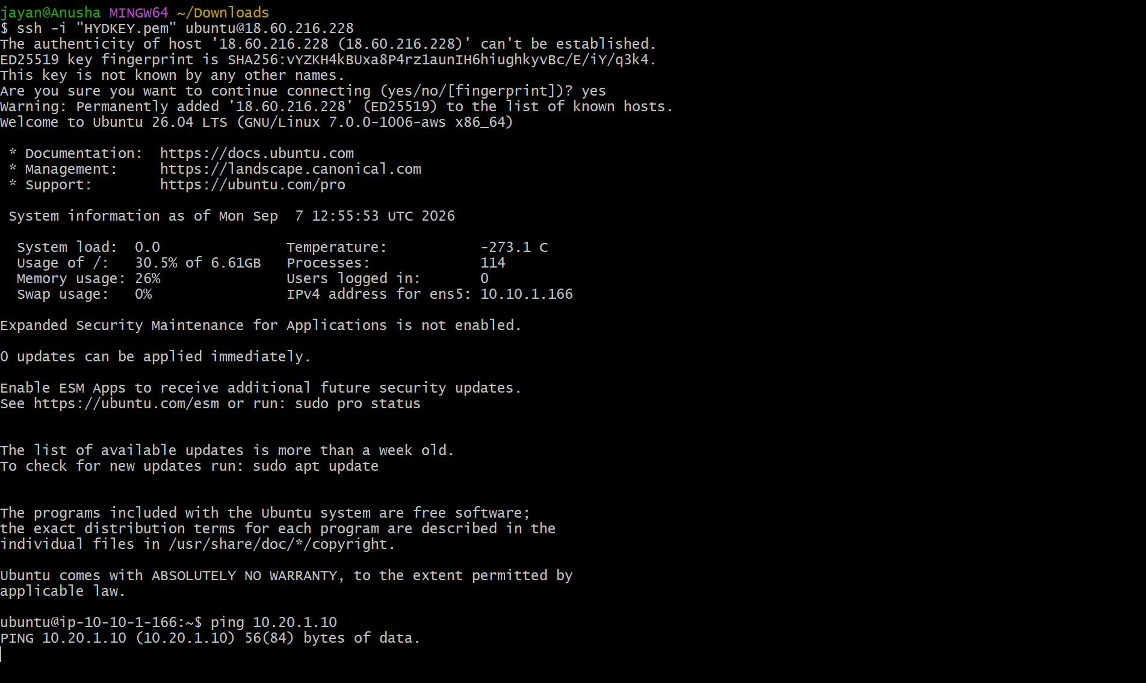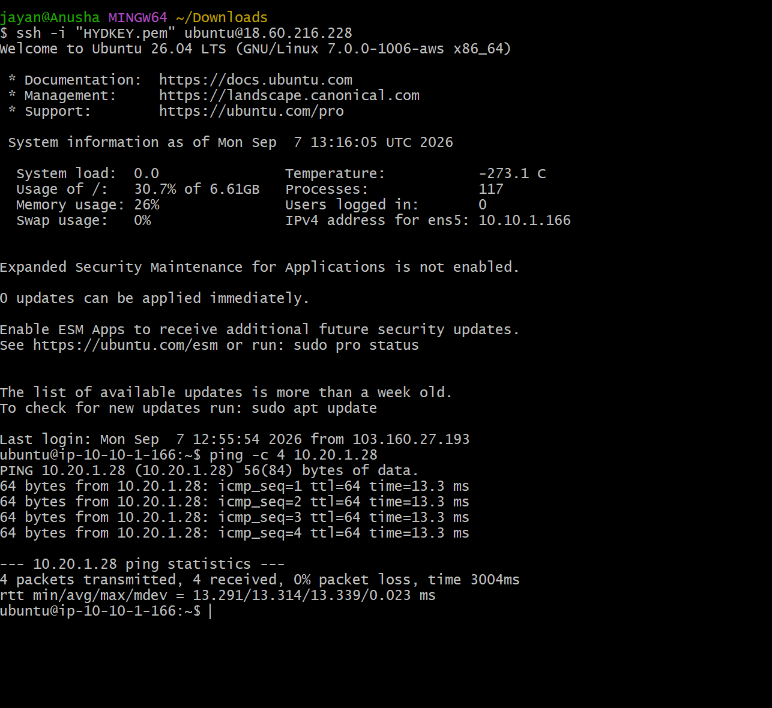
- VPC peering status should show Active.
- Both route tables should contain routes to the remote VPC CIDR through the peering connection.
- Security groups should allow the required traffic.
- Connectivity should work using private IP addresses.

Expected Result
The EC2 instances in the two different Regions should be able to communicate privately through the cross-region VPC peering connection.

Task 2: Deploy a Static Website Using S3, CDN, SSL, Route 53 and GoDaddy
Purchase a domain, host a static website in Amazon S3, distribute it through a CDN, secure it with an SSL certificate, and map the custom domain using Route 53.

Objective
Deploy and expose a static website using S3 as the origin, a CDN for content delivery, an SSL/TLS certificate for HTTPS, and Route 53 for DNS.

Requirements
- A GoDaddy account.
- An AWS account.
- An S3 bucket for the website.
- A CDN distribution such as Amazon CloudFront.
- An SSL/TLS certificate in AWS Certificate Manager (ACM).
- A Route 53 hosted zone.
- A Slack channel or workspace for connectivity testing.

Tasks / Steps
1. Purchase one domain from GoDaddy.
2. Record the registered domain name and confirm that you have access to its DNS settings.
3. Create an S3 bucket using the required bucket name and region.
4. Upload the static website files, including index.html and any CSS, JavaScript, images, or other assets.
5. Configure the S3 website hosting/origin settings as required for the selected CDN architecture.
6. Create a CDN distribution and configure the S3 bucket as the origin.
7. Configure the CDN distribution to use HTTPS.
8. Request an SSL/TLS certificate in AWS Certificate Manager for the purchased domain and any required subdomain, such as www.
9. Complete certificate validation using DNS validation.
10. Attach the validated SSL certificate to the CDN distribution.
11. Configure the CDN default root object as index.html.
12. Create a Route 53 hosted zone for the purchased domain.
13. Create the required DNS record, such as an A/AAAA alias record, pointing the domain to the CDN distribution.
14. If the domain is registered with GoDaddy, update its authoritative nameservers at GoDaddy to the Route 53 nameservers assigned to the hosted zone.
15. Wait for DNS propagation and verify that the domain resolves to the CDN.
16. Update index.html in the S3 bucket with a clearly different version, such as a new title or message.
17. If necessary, invalidate the CDN cache for the updated object so that the latest index.html is served.
18. Open the custom domain in a browser and verify that the updated website is accessible over HTTPS.
19. Share the domain name in Slack and ask another user/system to test connectivity. 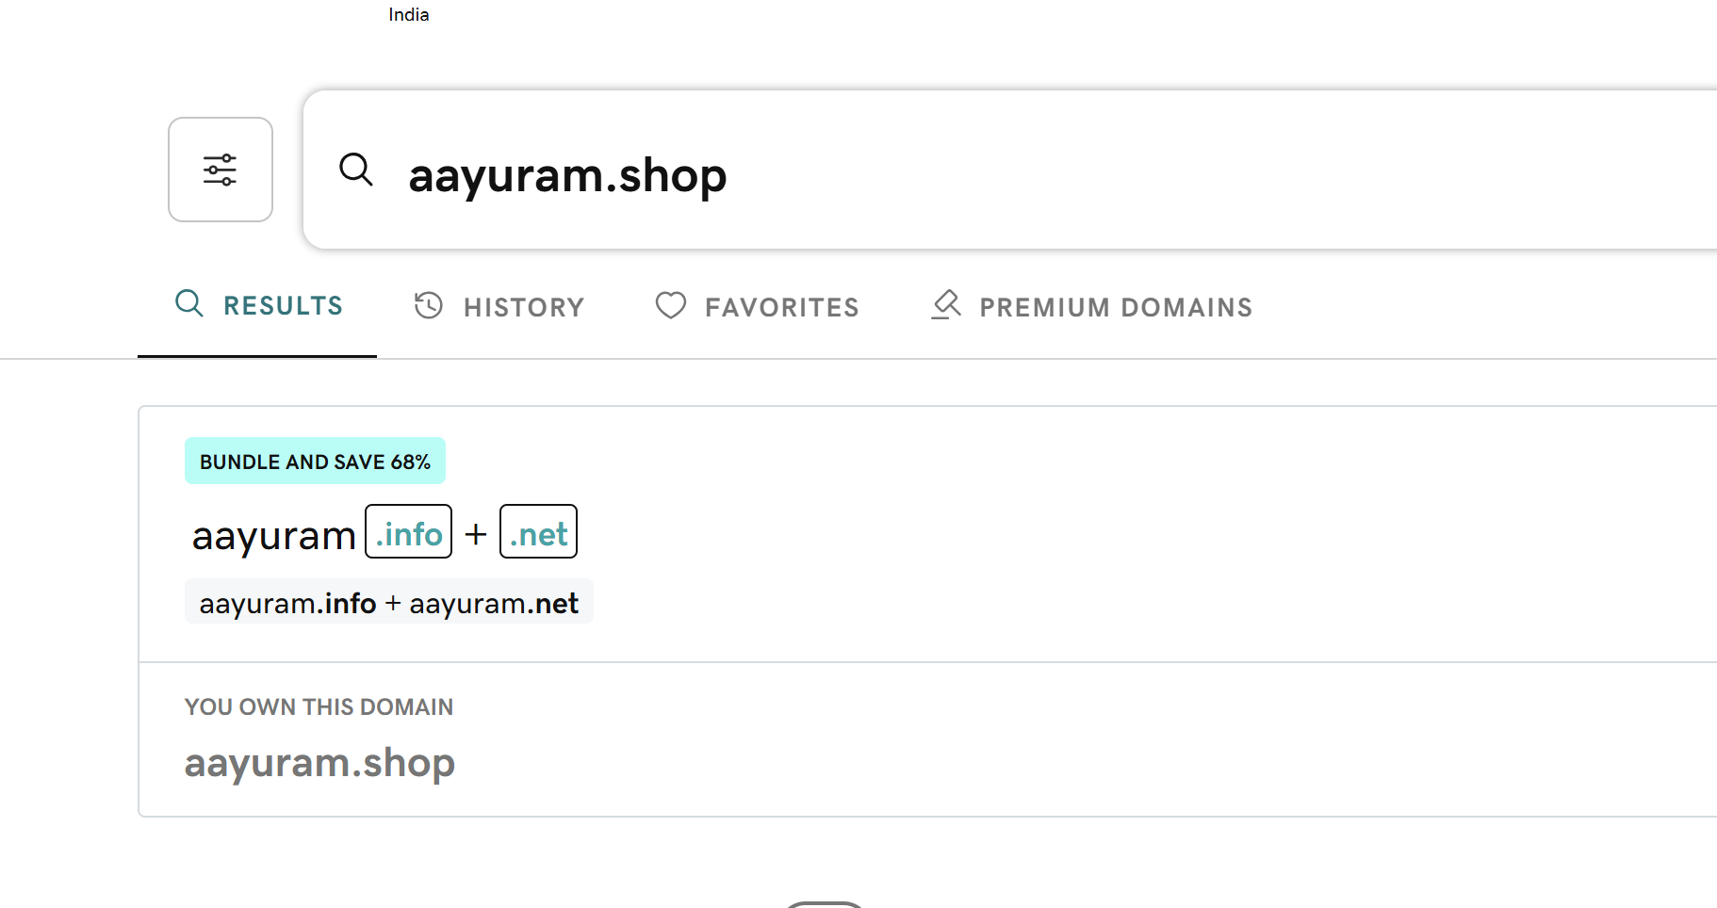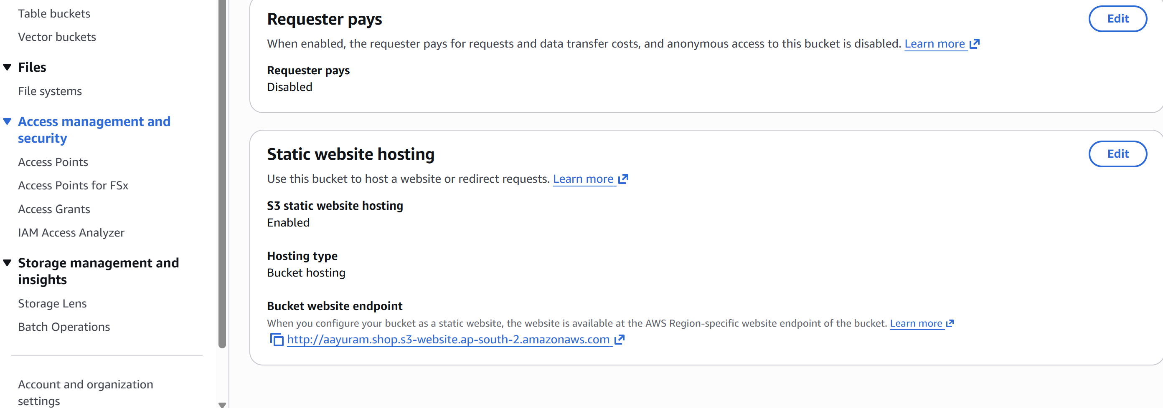

Suggested Website Test
Update index.html with a simple message such as: 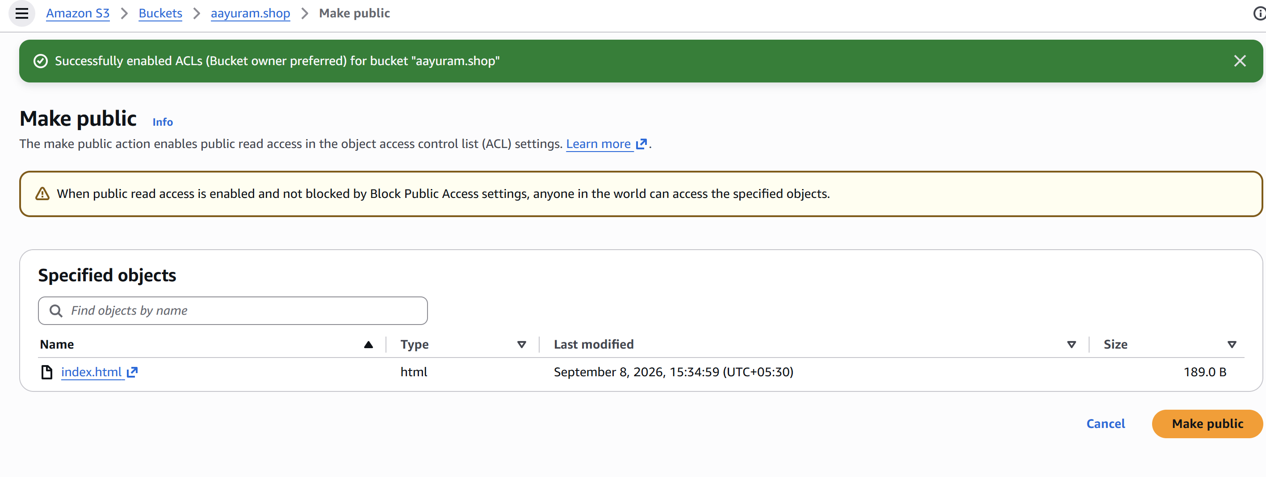
AWS Static Website Deployment - Version 2

Validation Checklist
- Domain is registered successfully with GoDaddy.
- Website files are uploaded to S3.
- CDN distribution is deployed and connected to the S3 origin.
- SSL certificate is validated and attached to the CDN.
- Route 53 hosted zone is created.
- GoDaddy nameservers point to Route 53, when Route 53 is being used as the authoritative DNS service.
- Custom domain resolves correctly.
- HTTPS works without a certificate warning.
- Updated index.html is visible through the custom domain.
- CDN cache has been invalidated when necessary.
- Domain is shared in Slack for connectivity testing.

Expected Result
The static website should be accessible through the purchased custom domain over HTTPS. The domain should resolve through Route 53 to the CDN, and the CDN should retrieve website content from the S3 origin. After updating index.html and refreshing/invalidation as needed, the new content should be accessible using the same domain.

Important Notes
- Do not use overlapping VPC CIDR ranges for VPC peering.
- For CloudFront, an ACM certificate used by the distribution must be provisioned in the US East (N. Virginia) Region.
- For a production website, prefer a private S3 bucket with CloudFront Origin Access Control rather than making the bucket publicly readable.
- DNS changes at GoDaddy may take time to propagate.
- CloudFront changes and deployments can also take time before they become fully active.

End of Practical Tasks

